**ASSIGNMENT 1**

**Team ID: PNT2022TMID27973**

TEAM LEADER: AISWARYAA V

TEAM MEMBER 2: AKALYA.S

TEAM MEMBER 3: HARINI.C

TEAM MEMBER 4: NACHAMMAI N

PROBLEM STATEMENT: 50- STARTUP DATASET

ADMINISTRATION AND PROFIT FOR STATE REGIONS

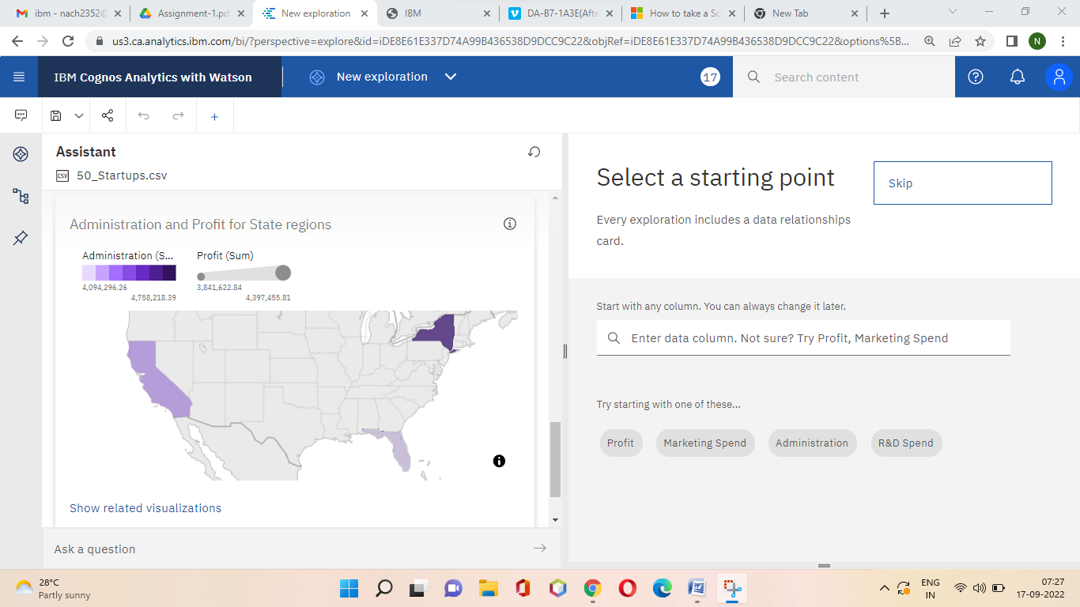

EXPLORE DATA RELATIONSHIPS

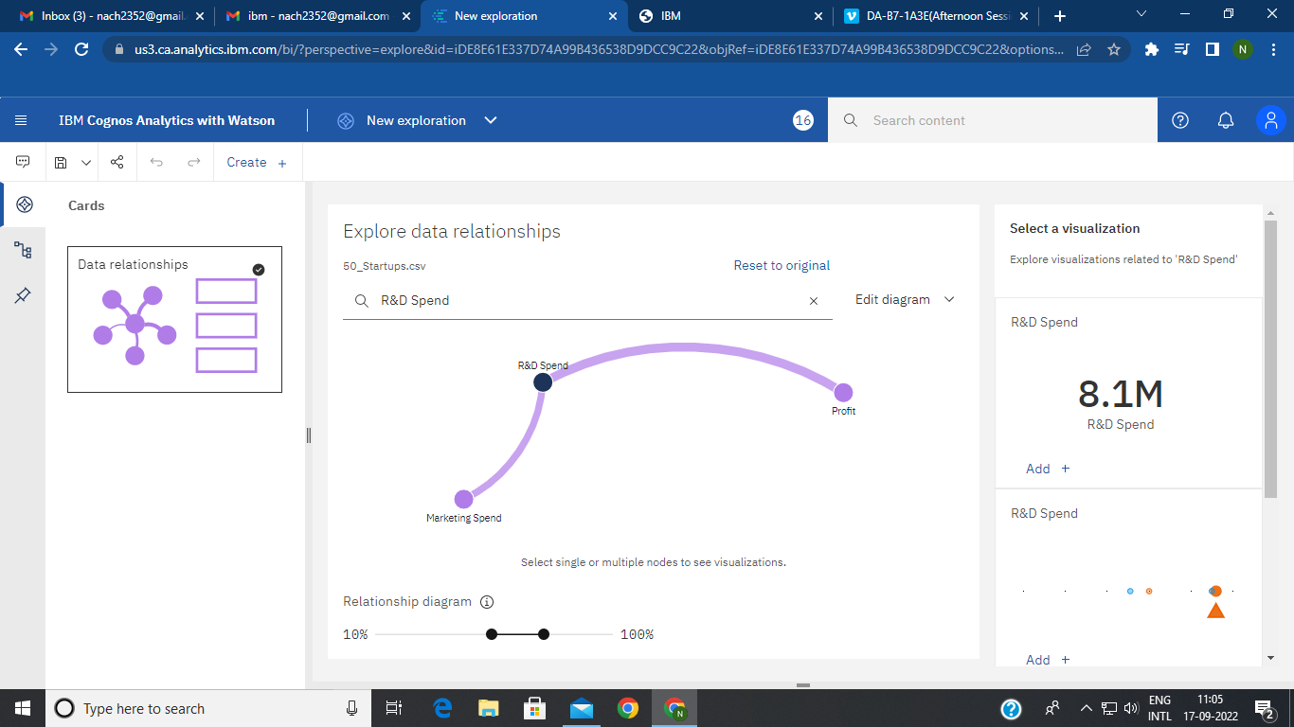

PROFIT BY STATE

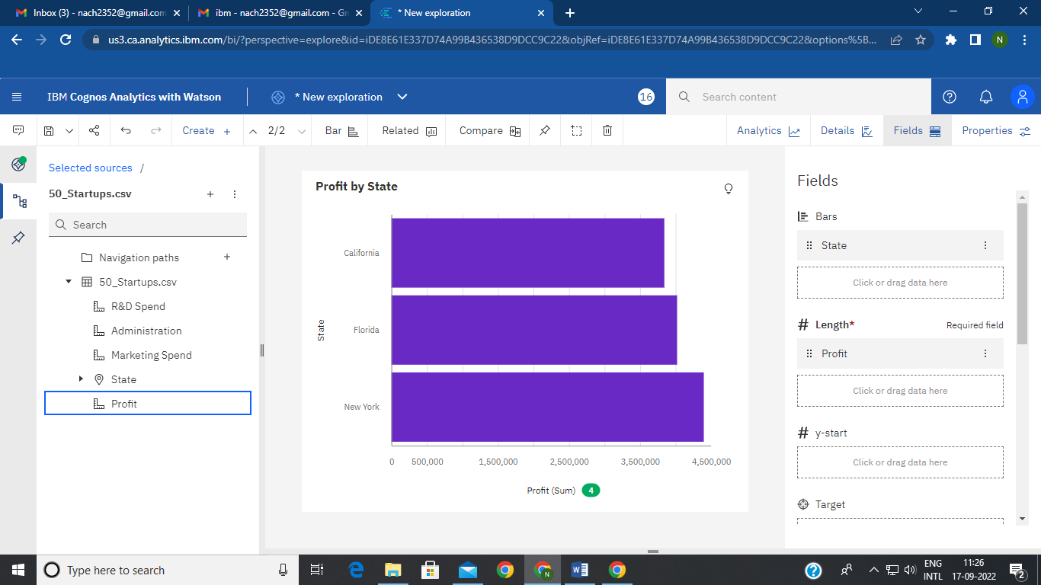

R&D SPEND BY STATE

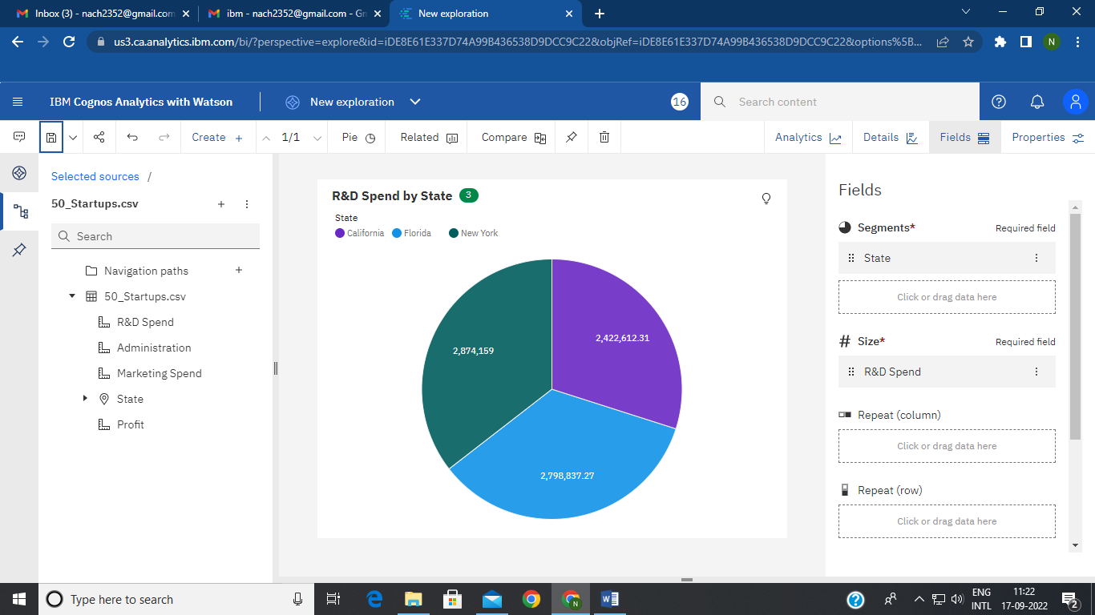

MARKETING SPEND BY R&D SPEND BY COLOURED ADMINISTRATION

